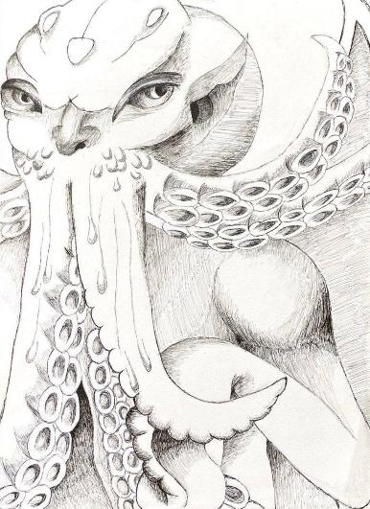

Tentaculus

* A mythical creature drawing, it a combination between octopus and human creature

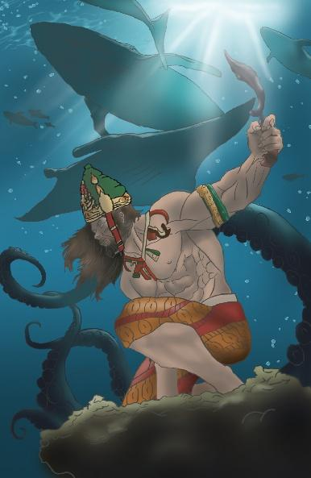

RAJA KIDUL

* It a art concept about Aquaman in Nusantara version

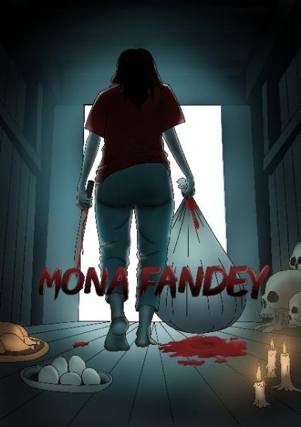

Mona Fandey Poster

* Dark side of our legendary Mona Fandey



Castle Emperor of Merrison



Journey Beyond the Pines Jacob and Kade

Name: Hasyimah Amirah Binti Hasan

Nickname: Syima

1 favourite quote

Make it simple, if your way to complicated just go to basic

-short bio (50-150 words max)

I'm someone who goes with the flow, embracing each moment without stressing about future plans. I believe in trusting the journey, even when the path ahead is unclear. Adaptable and open-minded, I face life with curiosity and calm, letting experiences shape me along the way.

Instagram : sy_amiys

Email: hasyimahhasan41@gmail.com